The Tragedy of Flight: A Comprehensive Crash Analysis

- INTRODUCTION

  - Overview

An airplane crash analysis is a detailed investigation into the cause an
aviation accident. The goal of an airplane crash analysis is to identify any
factors that contributed to the accident, with the ultimate goal of improving
safety and preventing future accidents.

The process of conducting airplane crash analysis typically involves the
collection and analysis of a wide range data, including information about the
aircraft and its systems, the operators, and any other relevant factors. This data
is typically collected from Kaggle. Once the data has been collected, it is
analysis through tableau, to identify any potential causes of the accident. The
result of an airplane crash analysis are typically published in a report, which
may include recommendations for improving safety and preventing similar
accidents in the future. These recommendations may be implemented by the
relevant authorities or industry organizations.

  - PURPOSE

Aviation accident analysis is performed to determine the cause of errors
once an accident has happened. In the modern aviation industry, it is also used
to analyze a database of past accidents in order to prevent an accident from
happening.
2. Problem Definition & Design Thinking.

2.1 Empathy map
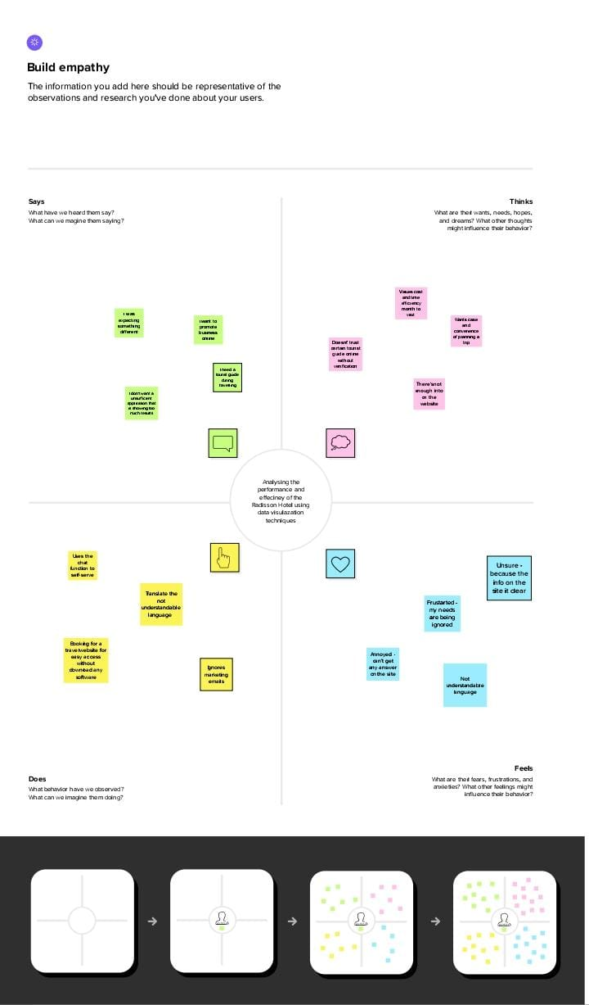
2.2 Ideation & Brainstorming map


3. Sheet

3.1 Comparing aboard

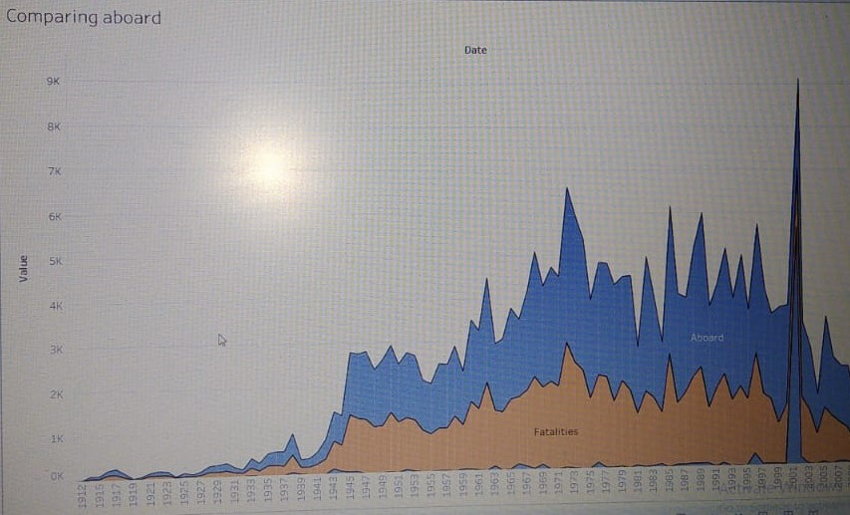
3.2 Maximum accidents based on years.
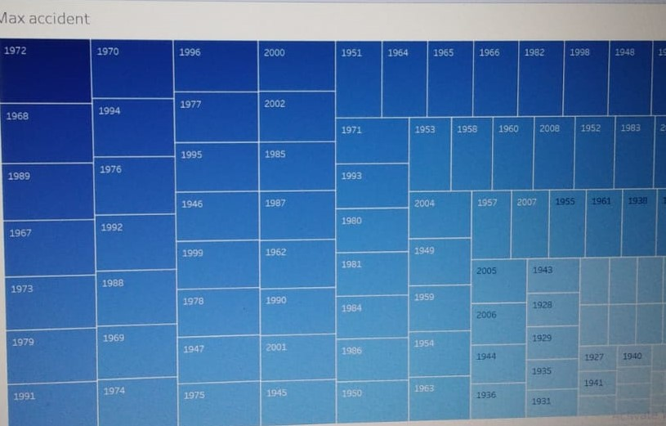

3.3 Accidents happened in 1972 (MAX ACCIDENTS) based on months.
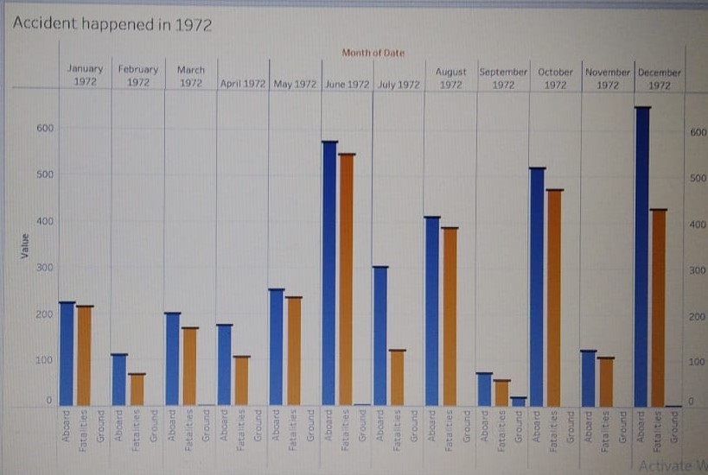
3.4 Highest no.of accident happened by operators.
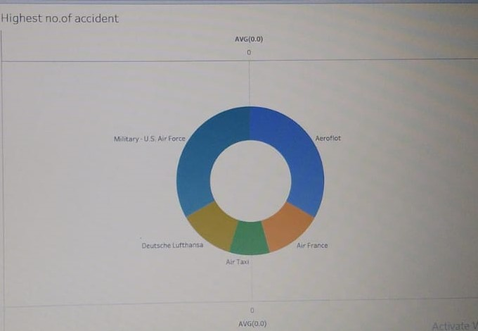
3.5 Top 10 locations which had more accidents
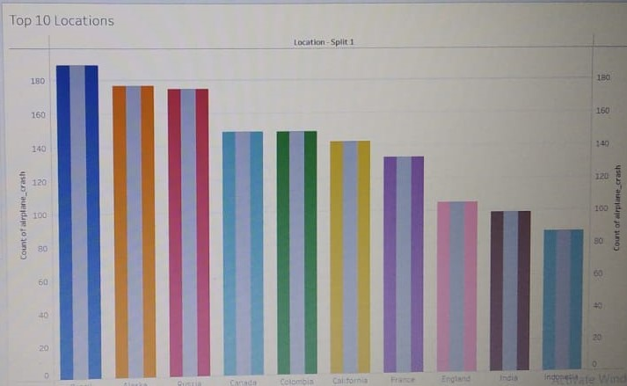

3.6 Top 3 flights which have maximum accident history.
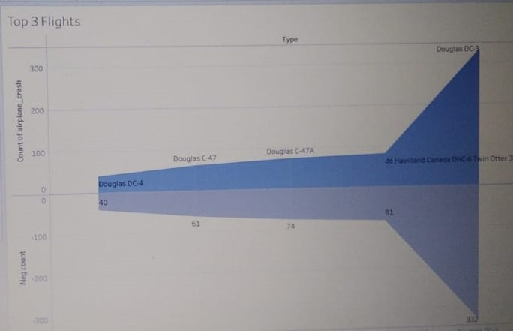

3.7 Accidents based on Regions.
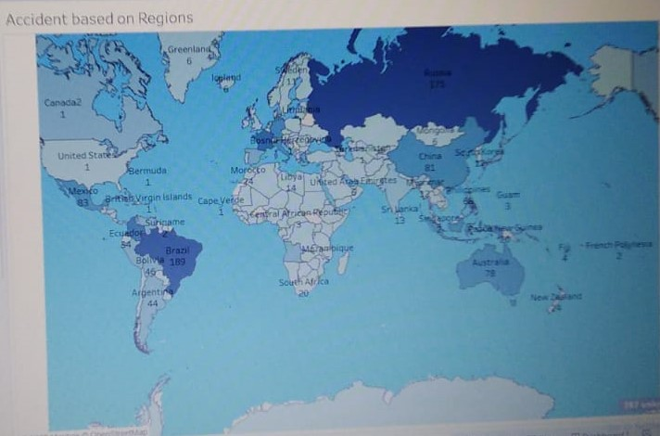

4 Dashboard
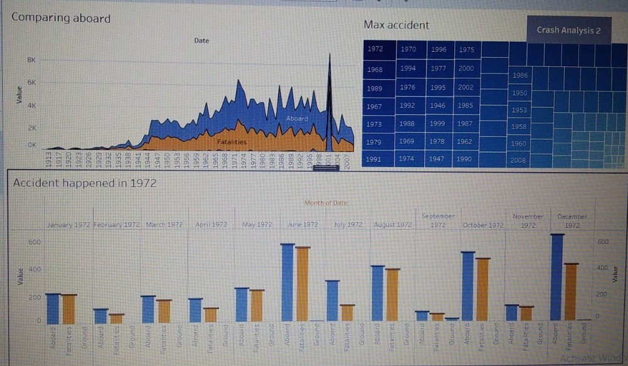

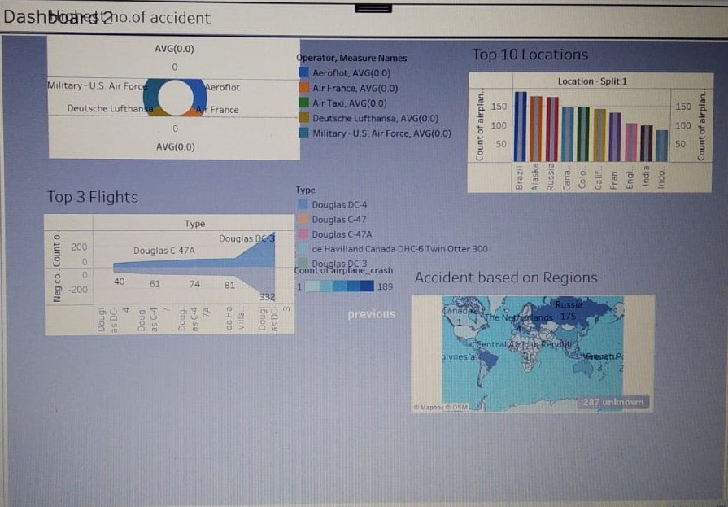

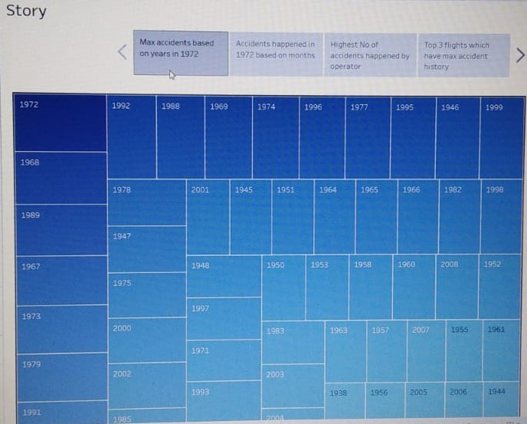
5 Conclusion

Thus a possible contribution of this systems to the accident
could be ruled one. Within the technical area, only “Flight controls” and
“Auto flight” could have contributed to the accident.

THANK YOU

